Dispatch

Mobile
EPTT

Fleet
Tracker
Satellite Failover

EPTT

Hours of Service

Brief
AT&T Fleet Complete Portal

Asset Tracker
Resource
Management

EPTT
EPTT

Resource Tracker

AT&T Fleet Complete® Hours of Service

The AT&T Fleet Complete Hours of Service (HOS) solution automates your drivers logbook keeping you in compliance and minimizing your financial risk.

AT&T Fleet Complete HOS mobile application automates the FMCSA
395.15 rule-compliant driver vehicle inspector reports (DVIR) keeping your drivers ready for inspectors anytime.

Avoid manual logging
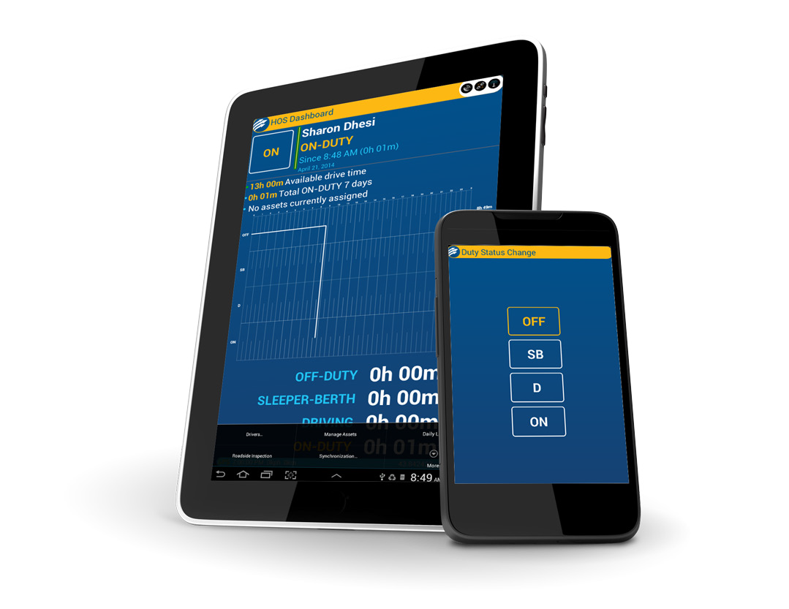
Instead of having to manually complete detailed calculations to ensure compliance with HOS rules, AT&T Fleet Complete HOS automatically logs the driver hours and calculates driver’s available ‘drive’ time for them, reducing their workloads. And rather than a paper logbook, drivers use their Android device to view their available hours, manage their status or complete vehicle inspection reports.

Painless roadside inspections
The application provides the roadside inspector all of the necessary information from the driver’s HOS Log, while keeping personal information private. If a driver ‘slip-seats’ vehicles, their current log can be easily moved with them.

Always audit ready
Driver information is shared automatically with fleet managers, and managers can retrieve each driver’s DOT Log on demand. They can review archived driver logs as required, and all of the electronic logs are easily accessible for any transportation authority in the event of an audit (MTO, DOT, etc).

Better dispatching
With access to every driver’s on-duty hours and availability, fleet manager dispatch decisions are easier to make helping to streamline fleet planning.
Compliant with the following regulations:
- FMCSA Rules 395.15
- Canadian SOR 2005-313, part 83
- FMCSA Rules 396.11
- DVIR NSC13

AT&T Fleet Complete® Hours of Service 2

AT&T Fleet Complete HOS Key Features

Driver logging
- Real-time display of current driver log
- View and change current driving status
- View total duty status report
- View available drive and long on-duty times
- Pop-up alerts for HOS rule violations
- Current and previous DVIR reports for each asset
- Select between authorized HOS Rules to accurately reflect the driver’s Available Driving Hour Warnings

Vehicle inspections
- Assign (hook) or un-assign (drop) trailers at any time
- Pre-populated fault descriptions for inspection reports
- Digital sign-off of Driver Vehicle Inspection Report
- View current and previous DVIR reports for each asset
- Fleet-specific DVIR forms available for a small onetime fee

Asset management
- Ability to “hook” or “drop” trailers, single or multiple
- Automatic logging of all asset hook or drop activity
- Perform DVIR inspections as unit are assigned

Fleet management
- View near real-time HOS status of all drivers
- View individual driver logs:
  - Available drive time, available cycle time, etc.
  - Total hours for each duty status
  - All assets/trailers assigned to each driver’s log
  - Odometer information for each powered asset
  - Summary of issues on all reports for assigned units
  - Total distance driven for the work day
  - Log type for US/CAN reports
  - Log sign-off
- Log Editing
  - Add and Edit non-driving events per FMCSA requirements

Technical Requirements

Mobile device requirements
- Android OS 4.0.3 or higher
- Bluetooth
- 1024x768 resolution for optimal display
- Fleet Complete HOS App installed
- WiFi capable OR Activated on SIM with Data Plan

Fleet Tracker requirements
- In-vehicle Fleet Tracker MGS150 installed
- Connection through OBD-II/CANBUS, J1939 or J1708 for full ECM integration

Office system requirements
- Windows 7 or newer
- Microsoft .NET Framework 4.5 or newer
AT&T Fleet Complete HOS Solution Details Hardware Requirements and Cost
•Bring Your Own Android Device
•AT&T Fleet Tracker MGS150 solution is required

For more information visit www.att.com/fleetcomplete or contact your local Fleet Complete Regional Sales Manager.

Important Information
AT&T Fleet Complete® is only available to customers with a Qualified AT&T business or government agreement and a Foundation Account Number (FAN) and their respective CRUs. Activation of an eligible AT&T wireless rate plan on a compatible device is required. May not be available for purchase in all areas or through all channels. Overage not available in all areas. Availability, security, speed, timeliness, accuracy and uninterrupted use of service are not guaranteed. Not all features available on all devices. Compatible device required for GPS or a GPS derived location information. Activating data blocking features will result in Cell ID or Enhanced Cell ID location information only. AT&T Fleet Complete® is subject to Complete Innovations’ additional terms and conditions, including without limitation its software license. Such terms and conditions are available at http:// downloads.fleetcomplete.com/ATT/eula.html. Additional hardware, software, services, internet access and/or special network connection may be required.

Pricing. Prices do not include taxes or other fees and are subject to change. Rates are not subject to any additional discounts under any AT&T discount plan. Additional credit and eligibility restrictions apply. Additional charges, terms, conditions and restrictions may apply. Offer and pricing subject to change without notice. AT&T privacy policy may be viewed at www.att.com/privacy.

02/09/16
© 2016 AT&T Intellectual Property. All rights reserved. AT&T and the AT&T logo are trademarks of AT&T Intellectual Property.

